Python Assignment 1
Answer Sheet
Student Name: | Shakhawat Hossain Shuvo

Problem 1: Answer
# Write your code here

s = input()

balance_list = []
cnt_L = 0
cnt_R = 0
st = 0
for i in range(len(s)):
if 'L' == s[i]:
cnt_L += 1
elif 'R' == s[i]:
cnt_R += 1
if cnt_L == cnt_R:
balance_list.append(s[st:i+1])
cnt_L = 0
cnt_R = 0
st = i+1
print(len(balance_list))
for item in balance_list:
print(item)

Problem 1: Screenshot of Accepted Code (If needed)
# Write your code here

Problem 2: Answer
# Write your code here

from collections import Counter

n = int(input())
arr = list(map(int, input().split()))

cnt = Counter(arr)
remove = 0
for x,c in cnt.items():
if c < x:
remove += c
elif c > x:
remove += c - x

print(remove)

Problem 2: Screenshot of Accepted Code (If needed)
# Write your code here

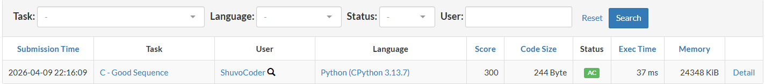

Problem 3: Answer
# Write your code here

Problem 3: Screenshot of Accepted Code (If needed)
# Write your code here

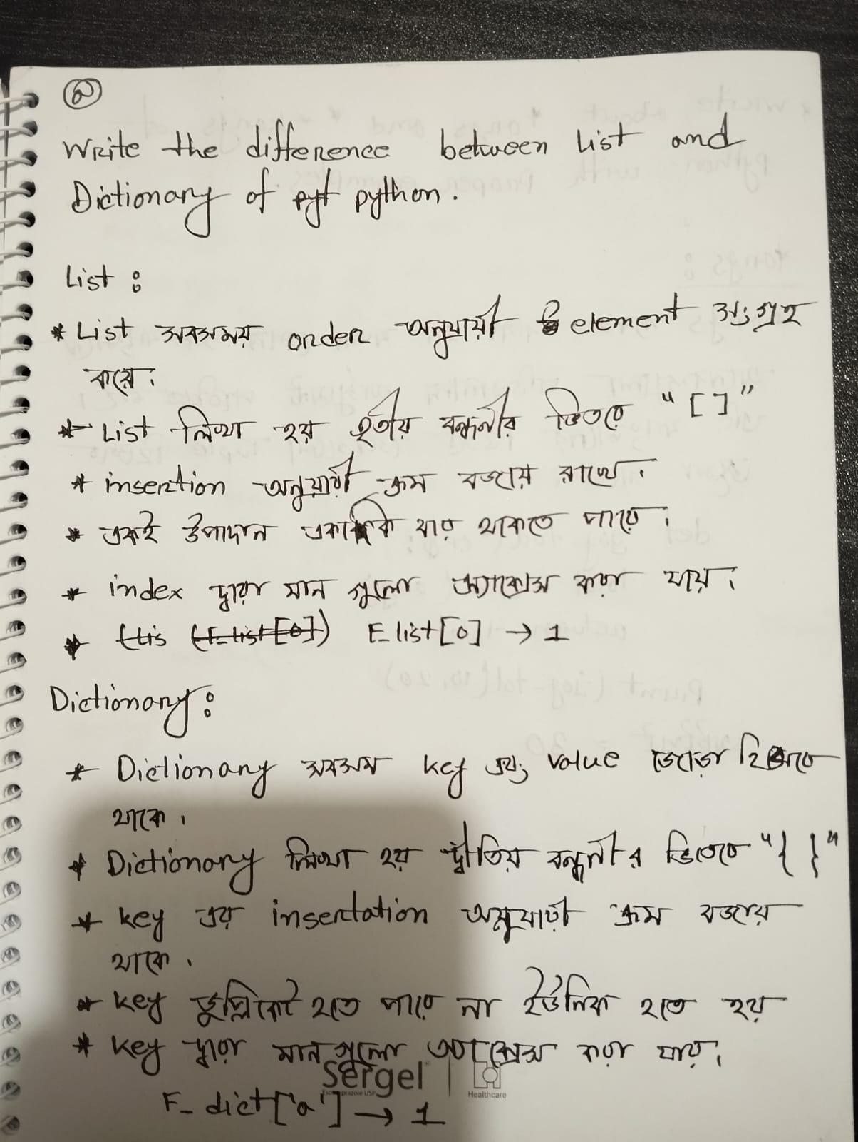
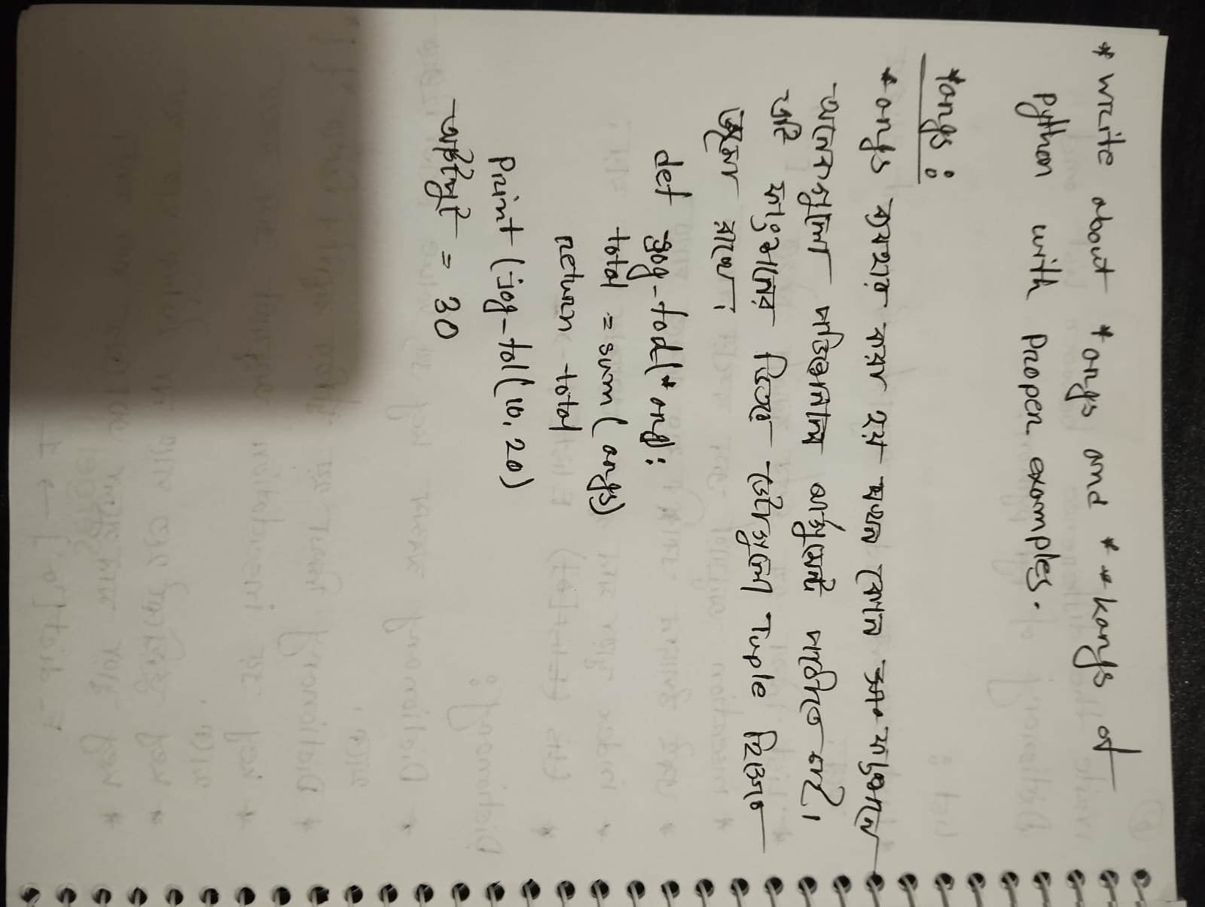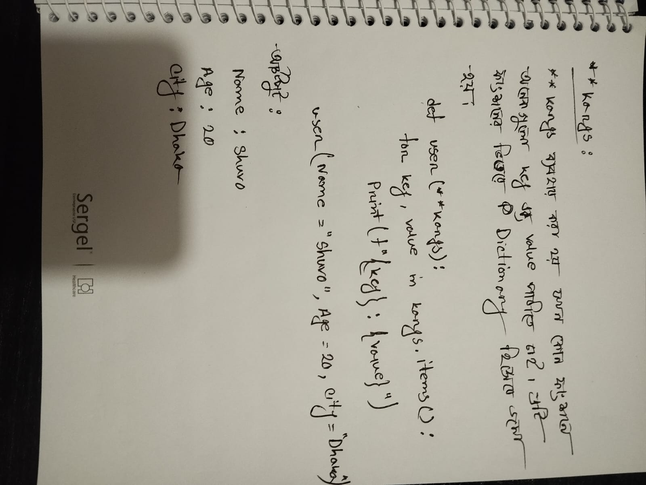

Problem 4: Answer
# Write your code here

n = int(input())
arr = list(map(int,input().split()))
cnt = 0
br = True
while True:
if not br:
break
for i in range(n):
if arr[i] % 2 != 0:
br = False
break

else:
arr[i] = arr[i] / 2
if br:
cnt += 1

print(cnt)

Problem 4: Screenshot of Accepted Code (If needed)
# Write your code here

Problem 5: Answer
# Write your code here

import pyautogui
n = int(input())
#n = 5
for i in range(1,n + 1):
pyautogui.write('*'*i)
pyautogui.press('enter')

Problem 5: Screenshot of Accepted Code (If needed)
# Write your code here

